Consolidated Change Request (UAT)
SIPRI Integration with Jal Rekha SVS Anushravan Module
Document | Complete and finalised change request – both modules in one document
Modules covered | A. SIPRI mobile app (Jal Rekha SVS Anushravan) | B. Jal Rekha SVS Anushravan web reports
Version | V 1.3 (updates V 1.2 – added process flow, A14 to A17, B3 and B4; A4, A11 and Field Engineer terminology updated)
Date | 12 October 2026
Total change items | 21 (Module A: 17, Module B: 4)
Prepared by | MPSeDC – MPSSDI/GIS Division

1. Purpose
This document consolidates all changes identified during UAT across both modules into a single list, so that the impact can be assessed and the changes implemented together. It is intended to avoid repeated modifications and to minimise disruption and instability for existing SIPRI users.
Changes in names, labels and messages are against the wireframes approved earlier and are marked here as the final required wording. Please treat this as the complete set of changes for this cycle.

2. Expected process flow
- The Gram Panchayat (GP) downloads the SIPRI app.
- The GP logs in and raises an RFI.
- The Sub Engineer is assigned to that GP.
- The Sub Engineer does the inspection and accepts or rejects the RFI.

3. Module A – SIPRI mobile app (Jal Rekha SVS Anushravan)
Ref | Screen / Area | Login / Role | Observed in UAT | Required change
A1 | App – module name | All users | Module name inside the SIPRI app is shown as "Jal Nigam GP". | Display the module name as "ANUSHRAVAN". Do not use "Jal Nigam GP". Correct spelling is "Anushravan".
A2 | App – user designation | Sub Engineer (SE) | User designation is shown as "Jal Nigam FE". | Display the designation as "Sub Engineer". Do not use "Jal Nigam FE".
A3 | RFI status | GP / SE | After the RFI is accepted or rejected, the status still shows "Verify". | Show "Verified" only after the RFI inspection has been completed.
A4 | RFI submission – confirmation | SE | The confirmation pop-up reads "Site approved successfully by SE" (Screenshots 3 and 9). | On submission, display the message "RFI submitted successfully by SE".
A5 | RFI History | SE | The RFI History list / tab is not visible after a successful RFI submission. | Make the RFI History tab and list available at SE login after submission.
A6 | RFI History – remarks | GP | Sub Engineer remarks are not visible in the GP login history. | Display the remarks entered by the Sub Engineer in the GP RFI History.
A7 | RFI History – photographs | GP | After the RFI is attended, only one photograph is available in the history. | Display both photographs in the GP login history: the "GP Field Photo" and the "Sub Engineer (SE) Field Photo".
A8 | RFI History – GP photo button | GP | After the RFI request is submitted, the GP photo cannot be viewed in RFI History. | Make the photo viewable in RFI History under GP login. Name the button "GP Field Photo".
A9 | Photo viewing | GP / SE | Photos open as a URL / file download (Screenshot 4: "Choose where to download"). | View photos in the app as an image (jpg). Do not present them as a URL or a download.
A10 | RFI create request form | GP | The form is displayed in English. | Provide the RFI create request form in Hindi.
A11 | Village dropdown | GP | Villages show under the dummy user but not under the GP user ID; the alert "No village found for your Gram Panchayat. Do you want to retry?" appears (Screenshot 2). The GP login response for Gram Panchayat Sodhiya returns District Sehore, Block Nasrullaganj and LGD code 149315, while the app screen showed District Sagar. | Check the village list again for this GP user and fix it, including the district / block / LGD mapping used to fetch villages. Genuine GP user credentials and the registered mobile number are to be shared for verification.
A12 | SE form submission | SE | Submitting the verification form for RFI Id 18 fails with the error: relation "pnrd.res_jranu_site" does not exist (Screenshot 1). | Resolve the database error so the Sub Engineer can submit the form successfully.
A13 | RFI request form – inspection date | GP | The "Date of inspection" field was not available in the form. It now appears on the GP RFI form (Screenshot 7). | Keep the "Date of inspection" field in the form.
A14 | App – header title | GP / SE | The header shows "Jal Rekha Anushravan" on the GP form, Verification and History screens (Screenshots 3, 7, 9, 10). | Remove "Jal Rekha" from the top header and keep only "Anushravan".
A15 | RFI request – confirmation | GP | On submission of the RFI request, the pop-up reads "Jal Rekha data submitted successfully" (Screenshot 7). | Replace the message with "RFI Request Raised Successfully".
A16 | Terminology – Field Engineer | GP / SE | The screens use "Field Engineer (FE)" in the photo screen title, button and remark label (Screenshots 8 and 10). | Write "Sub Engineer (SE)" instead of "Field Engineer (FE)" throughout the app, including the History page at both GP and SE logins (for example "Sub Engineer (SE) Field Photo").
A17 | Assignment and inspection flow | GP / SE | Process requirement – see Section 2. | A Sub Engineer must be assigned to the Gram Panchayat. The Sub Engineer must do the inspection and Accept / Reject the RFI.

4. Module B – Jal Rekha SVS Anushravan web reports
Ref | Screen / Area | Login / Role | Observed in UAT | Required change
B1 | Reports – Sub Category | Web user (GP login) | The Sub Category column in the web report shows Null / empty values. | Populate the Sub Category column correctly in the web report after checking the underlying data. Applies to the web report only.
B2 | Reports – access | All web user logins | Reports are not visible to all web user logins that have been created. | Make the report available and visible to all web user logins.
B3 | Anushravan GP Report – dates | Web user | The inspection date is given by the GP user and the RFI submitted date is by the SE, but the two dates appear to be interchanged. The Inspection Date column is blank for most RFIs (Screenshot 5). | Check and correct the mapping so that "Inspection Date" shows the date given by the GP user and "RFI Submitted Date" shows the date of submission by the SE.
B4 | Anushravan GP Report – filter | Web user | The report offers only keyword search and download (Screenshot 6). | Add a filter to the report. Filter fields to be confirmed (see D2).

5. Dependencies and points for confirmation
D1 | Genuine GP user credentials and registered mobile numbers are required to verify the village dropdown (A11).
D2 | The fields on which the Anushravan GP Report should be filtered are to be confirmed (B4).

6. Reference screenshots
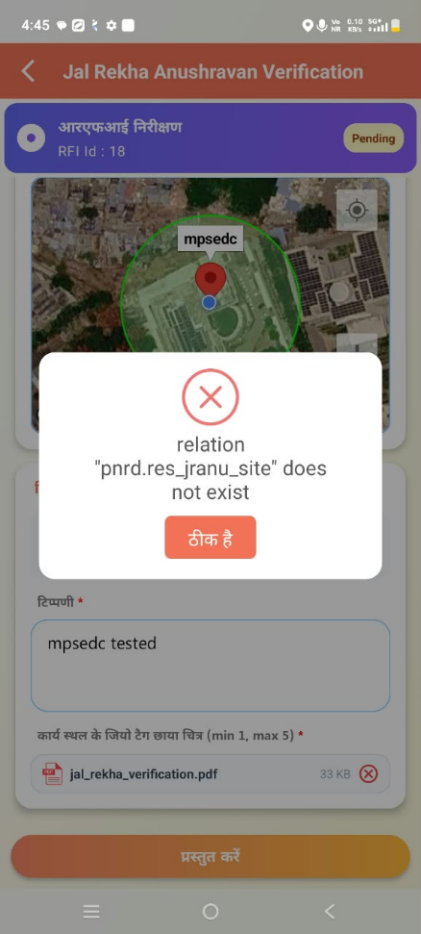  Screenshot 1: SE submit error (A12) | 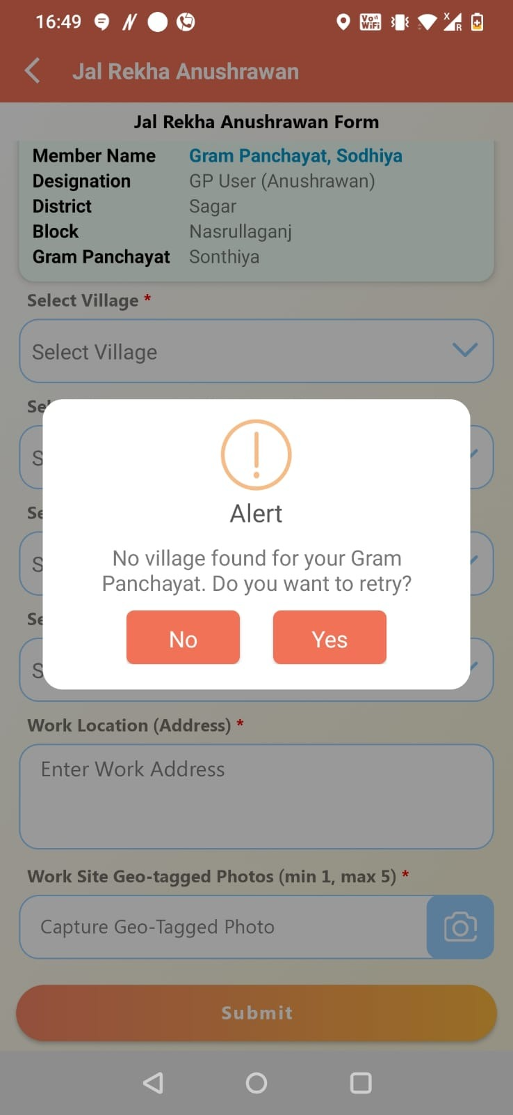  Screenshot 2: No village found, GP login (A11) | 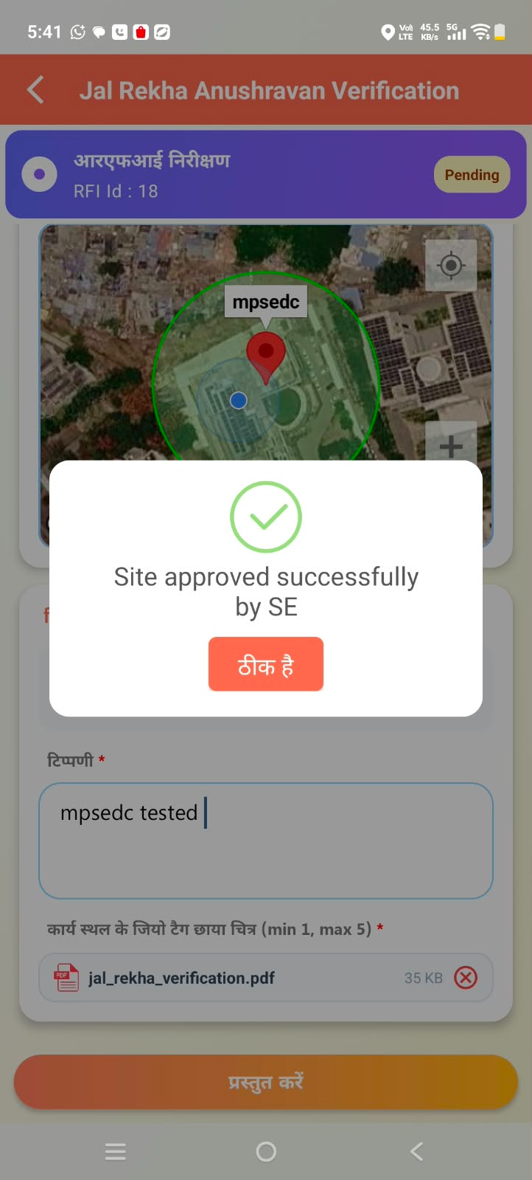  Screenshot 3: Confirmation text to change (A4) | 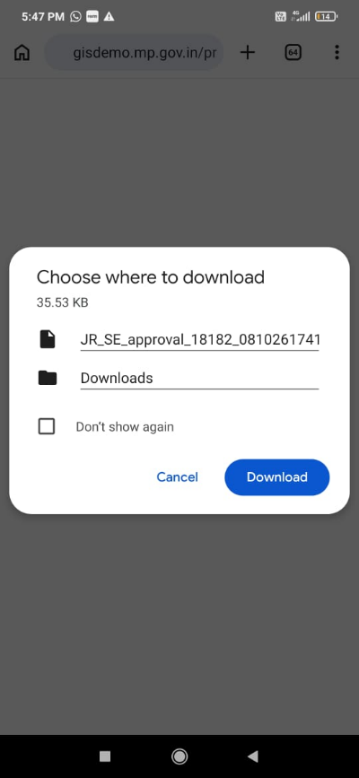  Screenshot 4: Photo download prompt (A9)

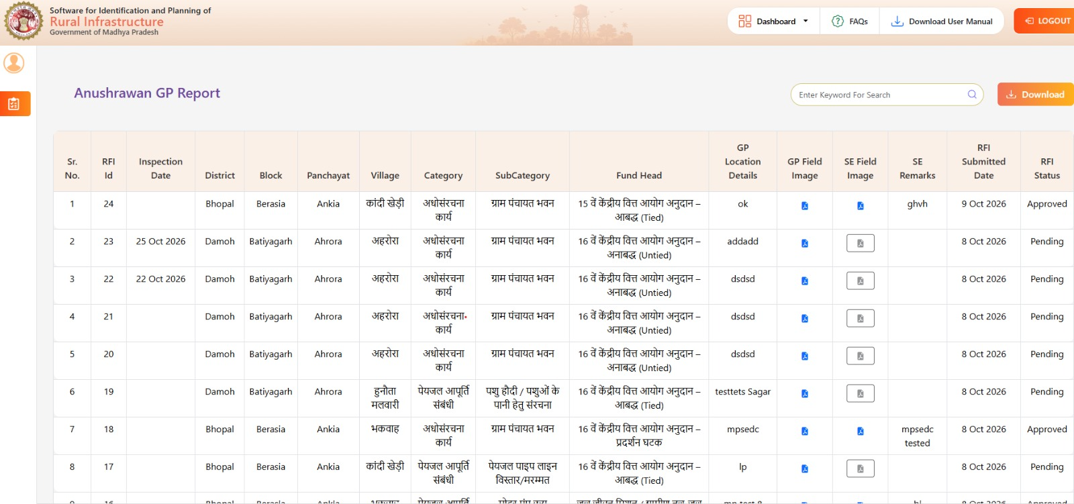
Screenshot 5: Anushravan GP Report: inspection date and RFI submitted date (B3)
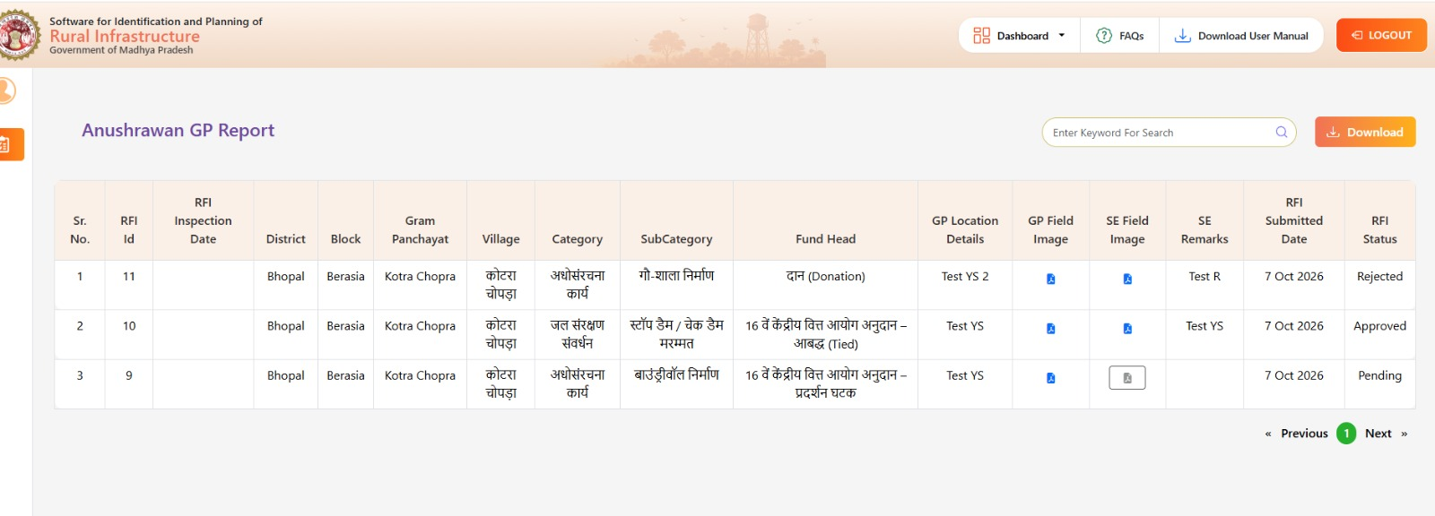
Screenshot 6: Anushravan GP Report: filter to be added (B4)

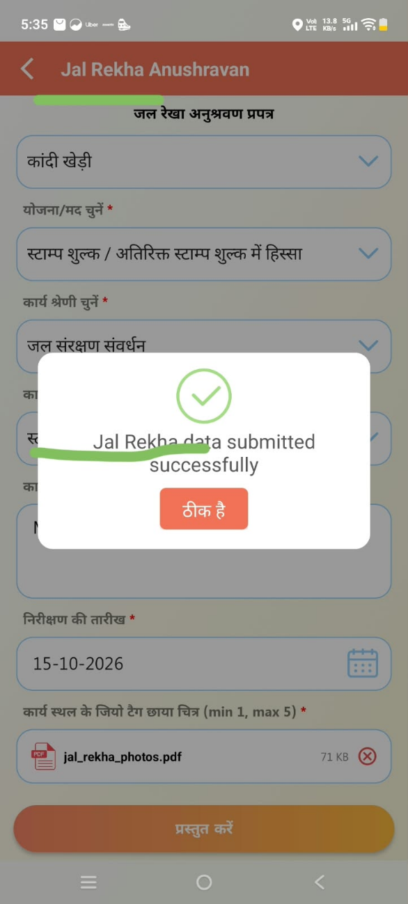  Screenshot 7: GP form: header and pop-up (A13 to A15) | 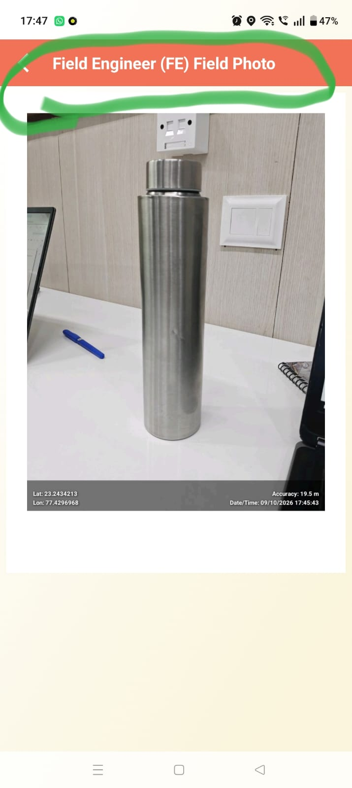  Screenshot 8: Field Engineer (FE) Field Photo title (A16) | 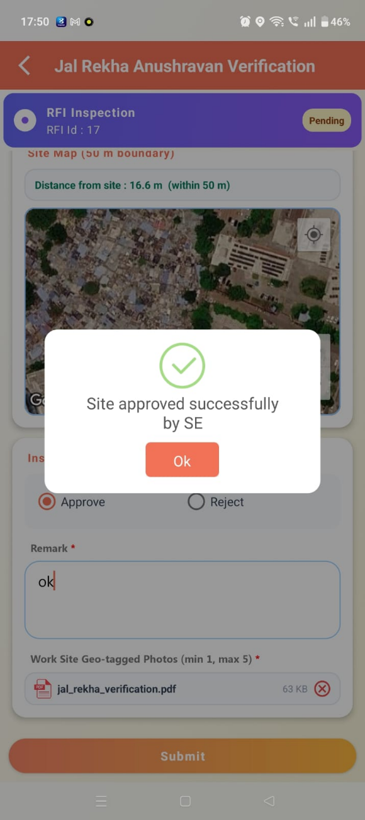  Screenshot 9: Confirmation message at SE login (A4) | 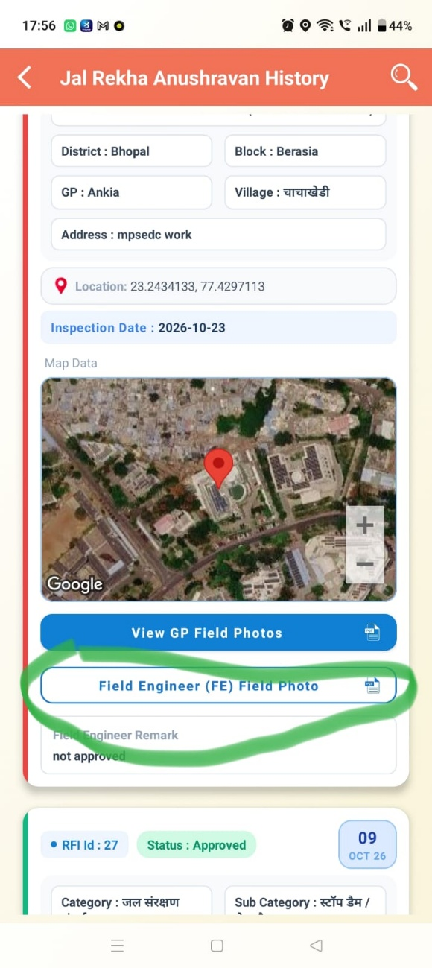  Screenshot 10: History page labels (A16)

